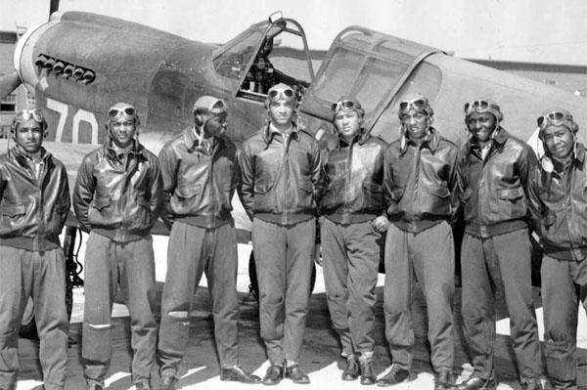The Tuskegee Airmen are recognised as the first African American military pilots. Trained for aerial combat they fought in World War II. Follow these links to learn of the role played by Mary McLeod Bethune in the creation of this group.

https://www.wsfa.com/story/218930/tuskegee-airmen/
https://www.timesheraldonline.com/2021/02/26/three-women-help-form-the-tuskegee-airmen/
https://en.wikipedia.org/wiki/Mary_McLeod_Bethune
https://www.military.com/history/the-tuskegee-airmen.html

